NAME:Rishik JK
REG.NO :192511052

CSA1702-ARTIFICIAL INTELLIGENCE
LAB EXPERIMENT

Experiment 14: Alpha-Beta Pruning Algorithm for Gaming

Aim
To write a Python program to implement the Alpha-Beta Pruning Algorithm for gaming.

Algorithm
- Start the program.
- Define the game tree with possible scores.
- Initialize Alpha as negative infinity and Beta as positive infinity
- The Maximizer selects the maximum value.
- The Minimizer selects the minimum value.
- Update Alpha and Beta during recursive evaluation.
- If Alpha is greater than or equal to Beta, prune the remaining branches.
- Display the optimal value.
- Stop the program
OUTPUT: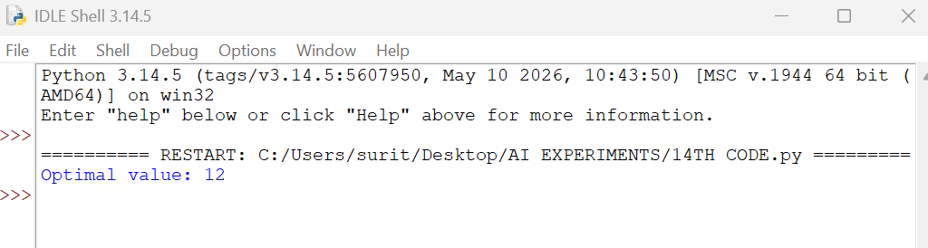

Result :Thus, the Python program to implement the Alpha-Beta Pruning Algorithm was successfully executed, and the optimal value was found to be 12 by pruning unnecessary branches.

